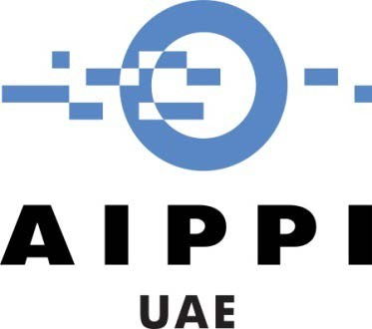
Sheikh Rashid Tower Seventh Floor
Dubai World Trade Centre PO Box 9204
Dubai - United Arab Emirates

3rd circular
April 7th, 2021

To all the members of the AIPPI UAE Group

The Current State of Geographical Indications Laws in the GCC

Dear all,
We hope that all of our members are doing well and keeping safe.
This is to update you that on 22 March 2021, the AIPPI UAE joined hands with the French Embassy in the UAE, Emirates Intellectual Property Association (EIPA), the Brand Owners’ Protection Group (BPG), and the French National Intellectual Property Institute (INPI), to co-organize a webinar on the subject of Geographical Indications Law, which was attended by more than 50 participants.
In this webinar, the AIPPI UAE member, Mr. Faisal Daudpota, gave a presentation overviewing geographical indications laws in the GCC countries. The other presenters included, Mr. Antoine Ginestet (the Coordinator for geographical indications at INPI), and Mr. Alexandre Levy (the Deputy-head of International Department at the French Institute National De L’Origine Et De La Qualite, aka INAO). The moderator for this webinar was Ms. Hoda Barakat, which is also a member of AIPPI UAE.
More specifically, Mr. Faisal Daudpota, presenting on behalf of AIPPI UAE, highlighted the following points:
- Examples of GIs from the UAE, Oman, and Saudi Arabia
- Unified GCC Trademark Law and Safeguards to GIs
- UAE Trademark Law and Safeguards to GIs
- Oman’s GI Protection Law (Sui Generis Protection System)
- Saudi Arabia’s Draft GI Protection Law (Sui Generis Protection System)
- Bahrain’s GI Protection Law (Sui Generis Protection System)
- Qatar’s GI Protection Law (Sui Generis Protection System)
- Future Options to Enhance Protection Through Additional Legislation
A PDF copy of this presentation is enclosed herewith for information.
Please feel free to contact the Communication Committee members if you like to write further on additional/new topics for future circulars that can benefit the members of AIPPI UAE.

Thank you,

The Communications Committee - AIPPI UAE Group

Authored by :Faisal Daudpota
Verified by :Hoda Barakat

