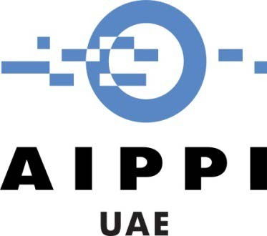
Sheikh Rashid Tower Seventh Floor
Dubai World Trade Centre PO Box 9204
Dubai - United Arab Emirates

1st circular
January 7th, 2021

To all the members of the AIPPI UAE Group

Major Amendment to the GCC Patent Law approved by GCC Supreme Council

Dear all,

We hope you are doing well and keeping safe.

The Communication Committee members take this opportunity to wish you all a successful year full of prosperity, safety and joy.

There has been a major change in the regional patent practice that is very important to share with all members. On 5 January 2021 the GCC Supreme Council approved the Amended Patent Law (Regulation) for the Gulf Cooperation Council.
While the amended GCC Patent Law has yet to be made available to the public, as of 6 January 2021, the GCC Patent Office will no longer accept new applications, i.e. IP holders can no longer choose to file “one application” covering all 6 GCC members. Applicants will have to go through the relevant national patent offices to obtain protection through the Paris Convention or PCT national phase. All laws, implementing regulations and local practices of these national patent offices will therefore apply to those new applications. It is likely that the GCC Patent Office will continue processing pending applications until grant unless the new amendment provides for other options.
Although it is still too early to give our full assessment based on the limited information available to us at the moment, it is quite reasonable to assume that the the cost of patent protection in the GCC countries will significantly increase from past estimates. This could of course pose a serious challenge to previously approved budgets for IP holders.
As for law firms, IP agents and prosecution service providers, this sudden change puts even more emphasis on the need to invest in Human Resources in the patent field. As the UAE is the second largest economy in the GCC and a global leader in innovation, we believe that it will become a focal point for regional patent filing strategies especially for applications that used to be previously filed with the GCC Patent Office.
We welcome all comments and views on this important subject from our members.
Thank you,

The Communications Committee - AIPPI UAE Group

Authored by : (Motasem Abu-Ghazaleh & Bassel El Turk)
Verified by : (Ziad Sunna)

